Assignment # 1 12/3/2012

**Name = NC – Saad Masood**

**Course = BESE – 16A**

**Submit to : Lt. Col. Saleem**

# Chapter 2

# SECTION 2-2 Electrical Charge

**3. How many coulombs of charge do 50 X 1031 electrons possess?**

Ans: = = 80 **X** 1012 C

**4. How many electrons does it take to make 80 µC (microcoulombs) of charge?**

Ans: 🡺 number of electrons = Q*(6.25 X 1018)

Number of electrons = (80 X 10-6) (6.25 X 1018) = 5 X 1014 electrons

# SECTION 2-3 Voltage, Current, and Resistance

**15. Find the conductance for each of the following resistance values:**

1. **5 Ω**
2. **250 Ω**
3. **100 Ω**

Ans: Conductance is G = 1/R

|  |  |  |
| --- | --- | --- |
| 1. G = 1/5 = 0.2 S | 1. G = 1/250 = 4 mS | 1. G = 1/100 = 10 mS |

**16. Find the resistance corresponding to the following conductances:**

* 1. **0.1 S**
  2. **0.5 S**
  3. **0.02 S**

Ans: R = 1/G

|  |  |  |
| --- | --- | --- |
| 1. R = 1/0.1 = 10 Ω | 1. R = 1/0.5 = 2 Ω | 1. R = 1/0.02 = 50 Ω |

# SECTION 2-4 Voltage and Current Sources

**19. How does an electronic power supply differ from the other sources of voltage?**

Ans: The power supply converts ac voltage to dc voltage.

**20. A certain current source provides 100 mA to a 1 kΩ load. If the resistance is decreased to 500 Ω, what the current in the load?**

Ans: using Ohm Law, V = IR = (0.1)(1000) = 100 V

Now I = V/R = 100/500 = 0.2 A

# SECTION 2-5 Resistors

**29. What resistance is indicated by 4K7?**

Ans: 4.7 kΩ

**30. Determine the resistance and tolerance of each resistor labeled as follows:**

**(a) 4R7J (b) 5602M (c) 150lF**

Ans:

# SECTION 2-6 The Electric Circuit

**35. Devise a switch arrangement whereby two voltage sources (VS1 and VS2 ) can be connected simultaneously to either of two resistors (R1 and R2 ) as follows:**

**VS1 is connected to R1 and VS2 connected to R2**

**or VS1 connected to R2 and VS2 connected to R1**

Solution:

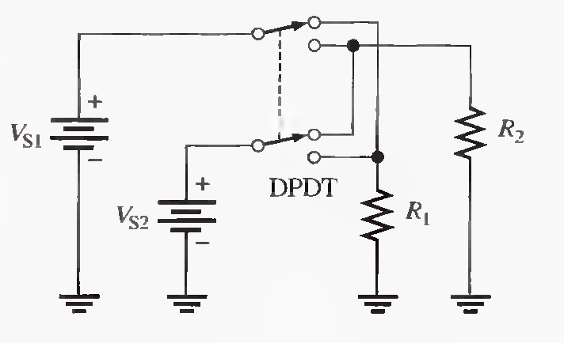

**36. The different sections of a stereo system are represented by the blocks in Figure 2-71. Show how a single switch can be used to connect the phonograph, the CD (compact disk) player, the tape deck, the AM tuner, or the FM tuner to the amplifier by a single knob control. Only one section can be connected to the amplifier at any time.**

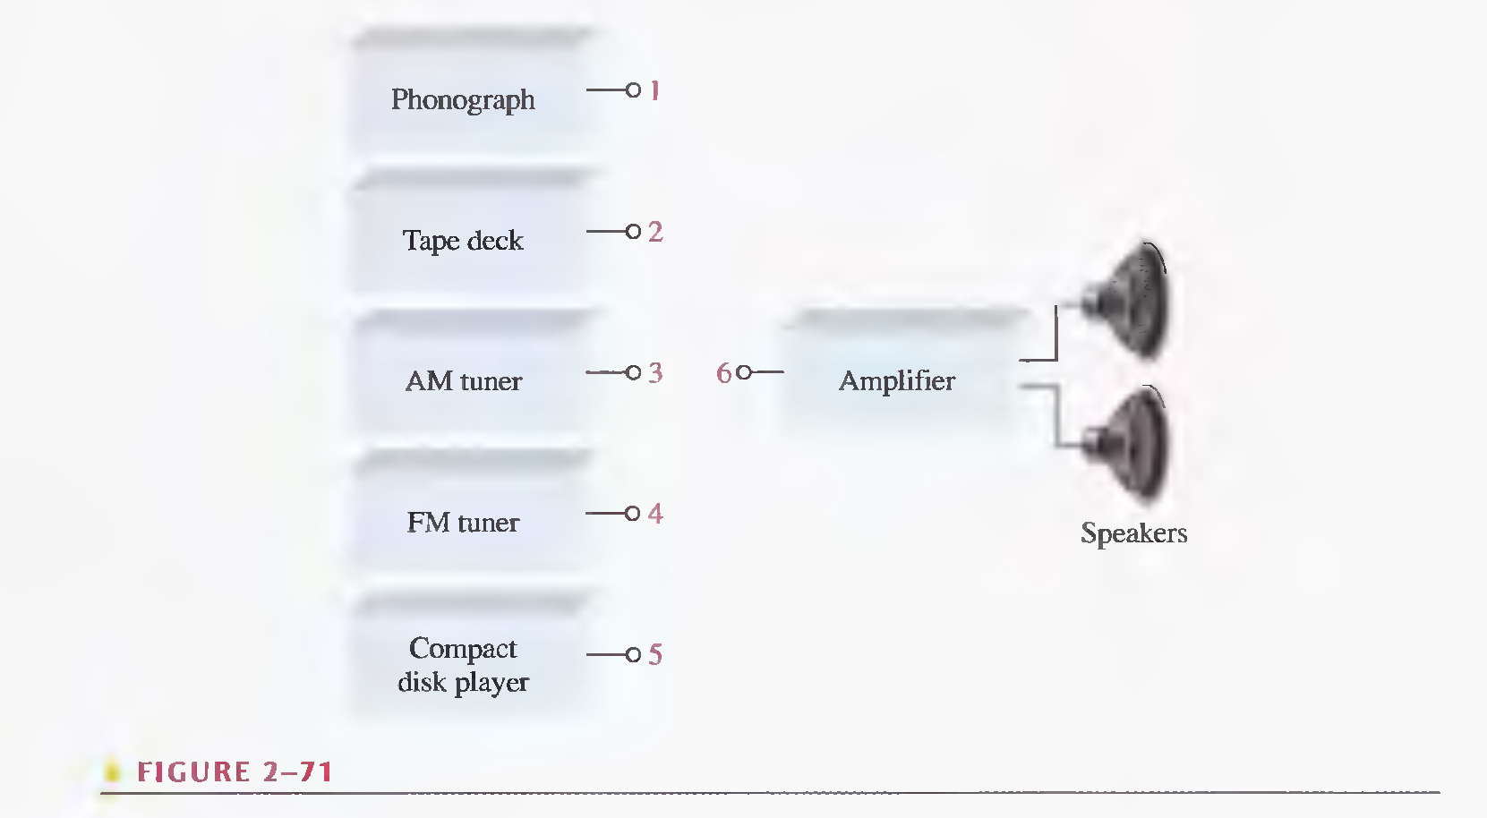

# SECTION 2-7 Basic Circuit Measurements

**46. What is the maximum resolution of a 4 * 1/2-digit DMM?**

Ans:

**47. Indicate how you would connect the multimeter in Figure 2-75 to the circuit in Figure 2-76 to measure each of the following quantities. In each case indicate the appropriate function and range.**

**a) I1 b) V1 c) R1**

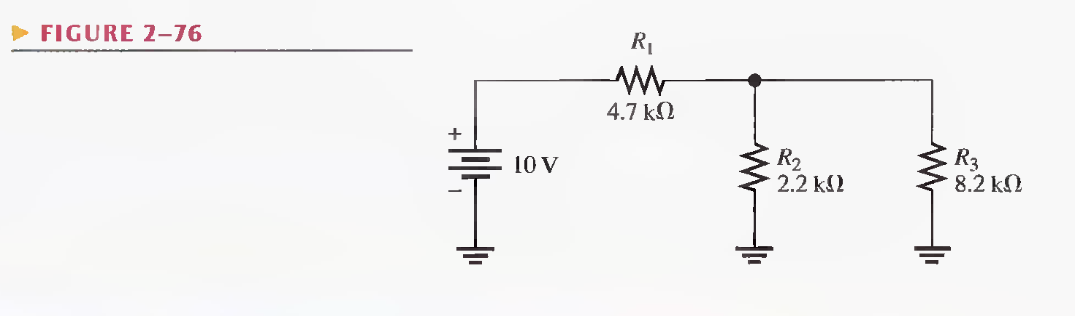

Solution:

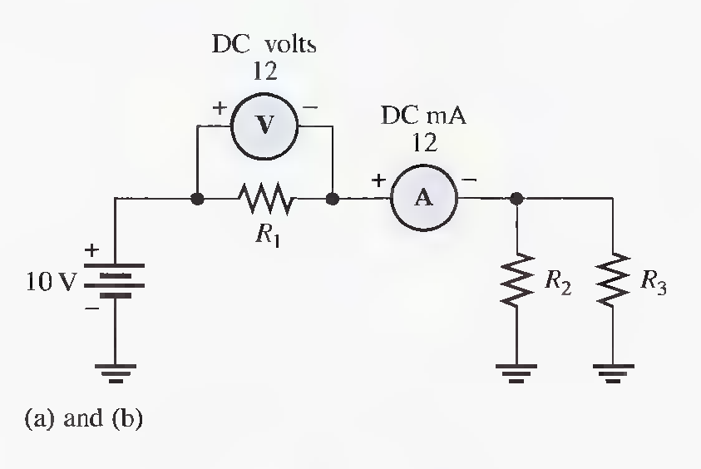 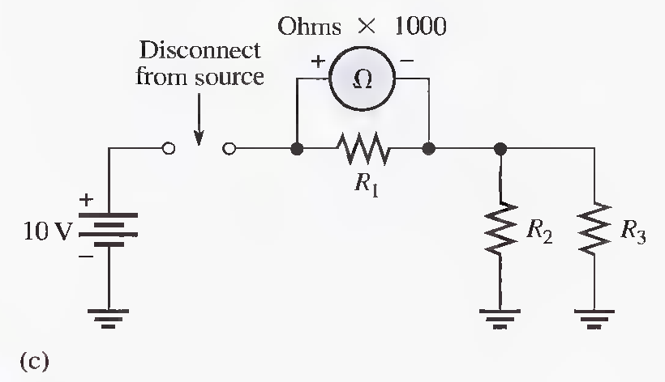

# Chapter 3

# SECTION 3-1 The Relationship of Current, Voltage, and Resistance

**13. Plot a graph of current versus voltage for voltage values ranging from 10 V to 100 V in 10 V steps for each of the following resistance values:**

**(a) 1.00 (b) 5.00 (c) 200 (d) 1000**

Ans:

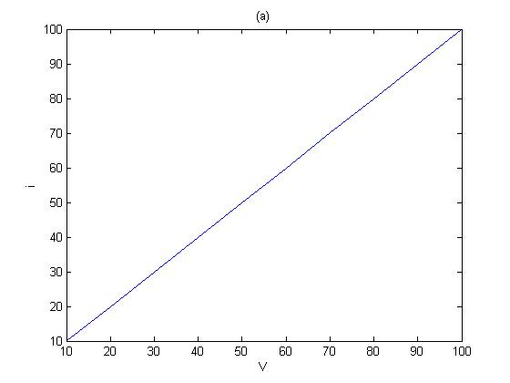 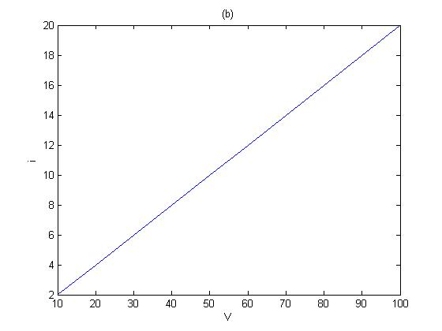

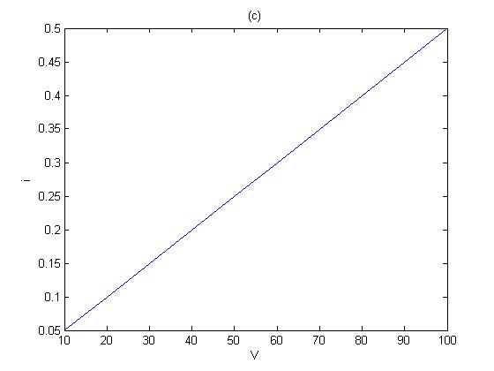 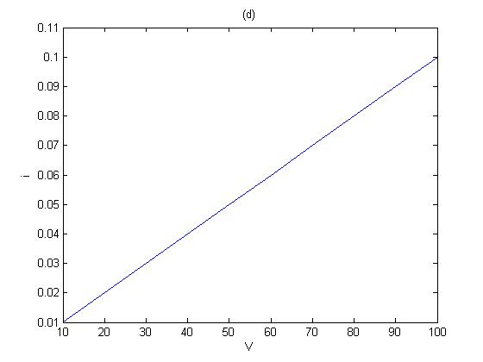

**14. Does the graph in Problem 13 indicate a linear relationship between voltage and current? Explain.**

Ans: yes, the graphs in Problem 13 indicate a linear relationship between voltage and current. As Ohm law, holds only for those devices/materials where the graph between V and I is straight line. The materials/devices holding Ohm law are called Ohmic devices/materials.

# SECTION 3-2 Calculating Current

**21. If the voltage in Problem 20 is doubled, will a 0.5 A fuse blow? Explain your answer. (20, A 5-band resistor is connected across a 12 V source. Determine the current if the color code is orange, violet, yellow, gold, brown.)**

Ans: after calculating current in question 20, value of current is 0.642 A.

As this current is 0.642 A, which exceed the rating of fuse.

**22. The potentiometer connected as a rheosrat in Figure 3-21 is used to control the current to a heating element. When the rheostat is adjusted to a value of 8 Ω or less, the heating element can bum out. What is the rated value of the fuse needed to protect the circuit if the voltage across the heating element at the point of maximum current is 100 V and the voltage across the rheostat is the difference between the heating element voltage and the source voltage?**

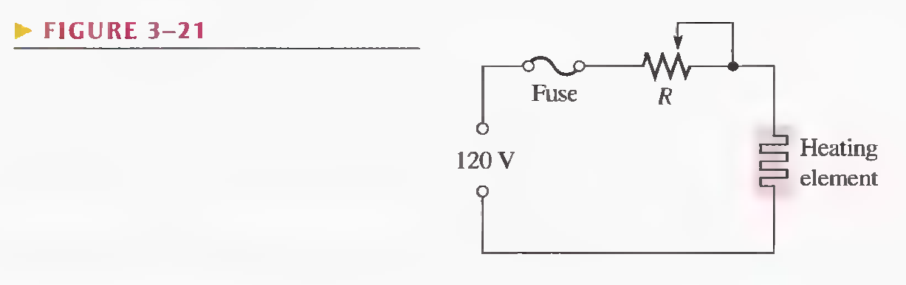

Ans:

# SECTION 3-3 Calculating Voltage

**26. Assign a voltage value to each source in the circuits of Figure 3-22 to obtain the indicated amounts of current.**

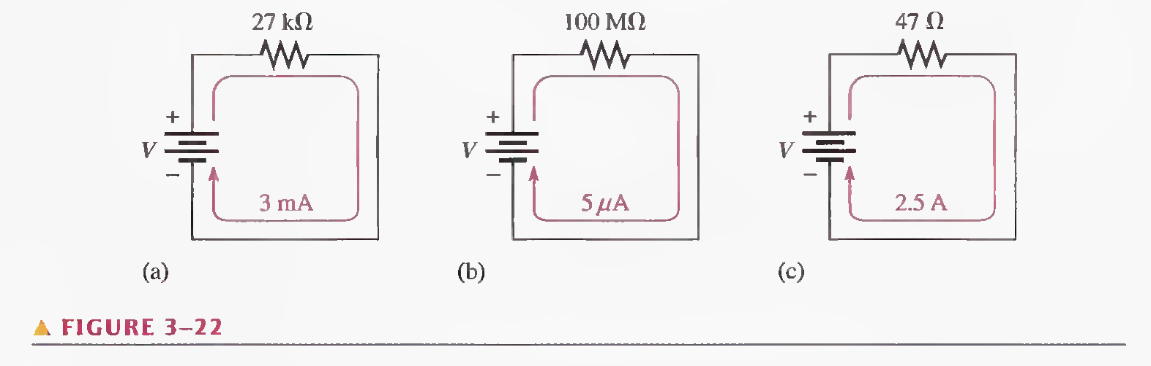

Ans: (a) V =IR = (0.003)(27000) = 81 V

(b) V = IR = (5µ)(100M) = 500 V

(c) V = IR = (2.5)(47) = 117.5 V

**27) A 6 V source is connected to a 100 Ω resistor by two 12 ft lengths of 18 gauge copper wire. The total resistance is the resistance of both wires added to the 100 Ω resistor. Determine the following:**

**(a) Current**

**(b) Resistor voltage drop**

**(c) Voltage drop across each length of wire**

Ans: a) R = 100.17 Ω

Using Ohm law, V = IR 🡺 I = V/R = 6/(100.17) = 59.8 mA

1. V = IR = (0.0598)(100.17) = 5.99 V

# SECTION 3-4 Calculating Resistance

**34. A 120 V lamp-dimming circuit is controlled by a rheostat and protected from excessive current by a 2A fuse. To what minimum resistance value can the rheostat be set without blowing the fuse? Assume a lamp resistance of 15** Ω**.**

Solution:

**35. Repeat Problem 34 for a 110 V circuit and a 1 A fuse.**

Solution: R = V/I = 110/1 = 110Ω

# SECTION 3-5 Introduction to Troubleshooting

**36. In the light circuit of Figure 3-25, identify the faulty bulb based on the series of ohmmeter readings shown.**

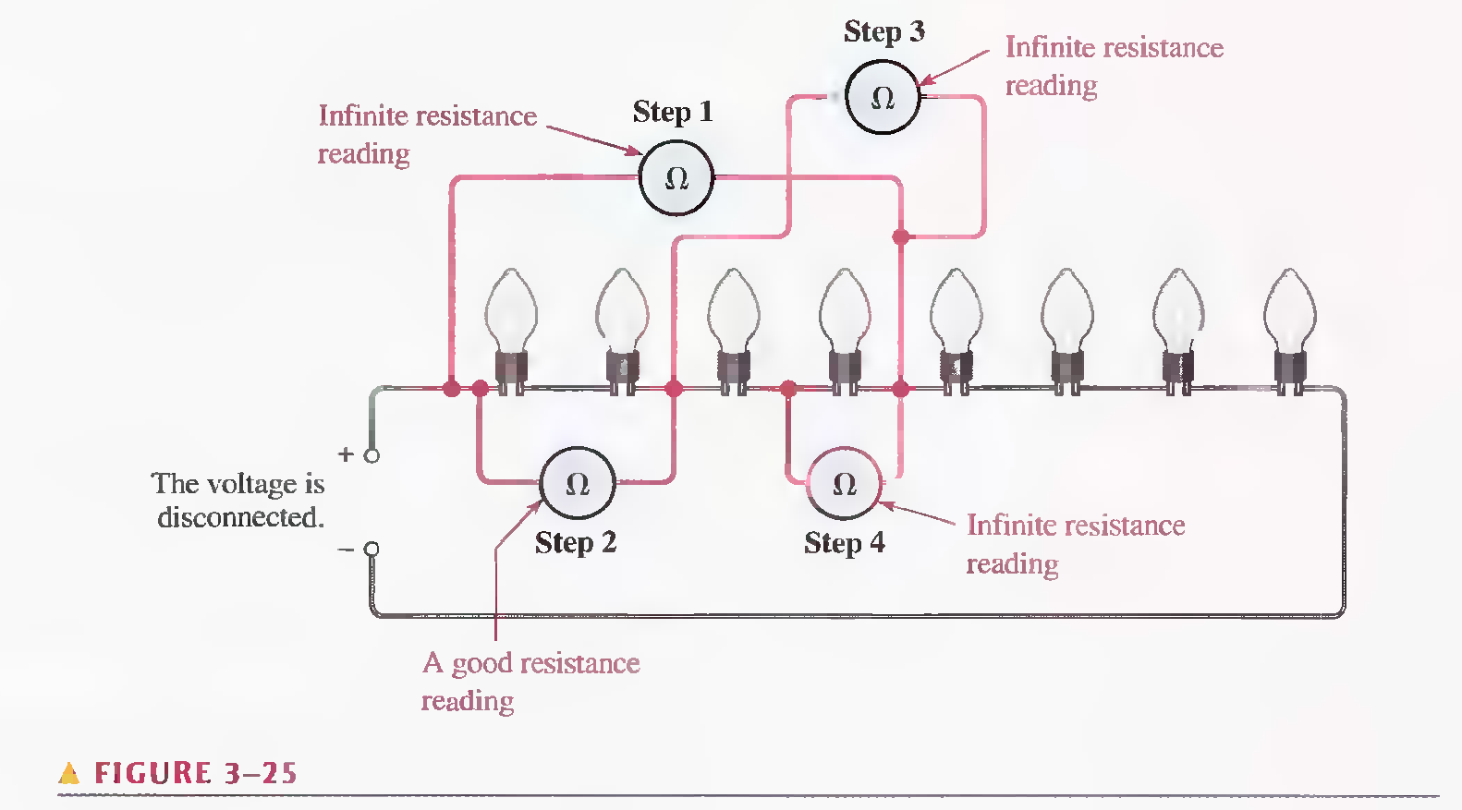

Solution:

# Chapter 4

# SECTI0N 4-1 Energy and Power

**15. Convert 6700 watt-seconds to kWh.**

Ans: 6700/(3600 X 1000) = 0.001861 kWh

**16. For how many seconds must there be 5 A of current through a 47 Ω resistor in order to consume 25J?**

Ans: P = I2R = (5)2(47) = 1175 W

P = W/t 🡺 t = W/P = 25/1175 = 0.1915 s

# SECTION 4-2 Power in an Electric Circuit

**24. If a resistor is to carry 2 A of current and handle 100 W of power, how many ohms must it be? Assume that the voltage can be adjusted to any required value.**

Ans: P = I2R 🡺 R = P/I2 = 100/22 = 25 Ω

**25. A 12 V source is connected across a 10 Ω resistor.**

**(a) How much energy is used in two minutes?**

**(b) If the resistor is disconnected after one minute, is the power during the first minute greater than, less than, or equal to the power during a two minute interval?**

Ans: a) P = V2/R = (12)2/10 = 14.4 W

P =W/t 🡺 W = P.t = (14.4)(2 x 60) = 1728 J

1. Equal

# SECTION 4-3 Resistor Power Ratings

**26. A 6.8 kΩ resistor has burned out in a circuit. You must replace it with another resistor with the same resistance value. If the resistor carries 10 mA, what should its power rating be? Assume that you have available resistors in all the standard power ratings.**

Ans: P = I2R = (0.01)2(6800) = 0.68 W

**27. A certain type of power resistor comes in the following ratings: 3 W, 5 W, 8 W, 12 W, 20 W. Your particular application requires a resistor that can handle approximately 8 W. Which rating would you use for a minimum safety margin of 20% above the rated value? Why?**

Ans: At least 12 W, to allow a safety margin of 20%

# SECTION 4-4 Energy Conversion and Voltage Drop in Resistance

**28. For each circuit in Figure 4-13, assign the proper polarity for the voltage drop across the resistor.**

Solution:

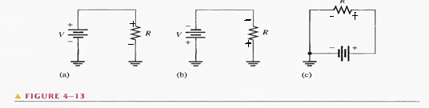

# SECTION 4-5 Power Supplies

**36. To operate at 85% efficiency, how much output power must a source produce if the input power is 5W?**

Ans: Efficiency = (Pout/ Pin)100%

85% =(Pout/5)100% 🡺 Pout = (0.85)(5) = 4.25W

**37. A certain power supply provides a continuous 2 W to a load. It is operating at 60% efficiency. In a 24h period, how many kilowatt-hours does the power supply use?**

Ans: WkWh = p.t = (2)(24) = 48 Wh = 0.048 kWh